NYS Coalition for the Aging &
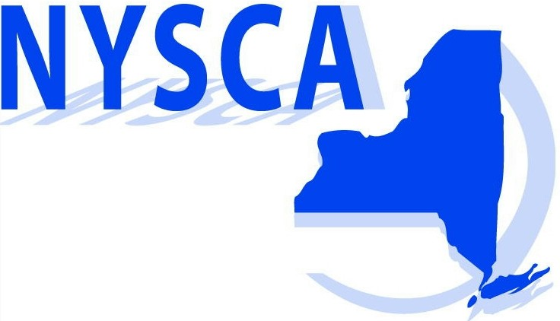
NYS Association of Area Agencies on Aging

“Hoarding: Finding A Way Out”

Speakers: Carmen L. Morano, Ph.D., Associate Professor; Hunter College School of Social Work, Managing Editor; Journal of Gerontological Social Work & Lou Pierro, Esq., Pierro Law Group, NYC & Albany, NY
October 6, 2010
1:00 p.m. - 4:00 p.m.

This training is a video conference that will be held at the following locations around the state:

Delmar
Port Henry
Plainview
New York City
Utica

Syracuse
Bath

Practitioners face unique challenges and dilemmas when they are working with elders who may not be able to manage their own affairs. Clinical concerns and ethical dilemmas that frequently occur when assessing the competence of cognitively impaired elders will be a prime focus of discussion. A particular emphasis will be placed on hoarding behavior, as a unique phenomenon among elders with dementia to illustrate the complex situations that can arise when working with this “hidden” population. Intervention strategies for working with difficult or resistant clients will be part of the solution.

Workshop Objectives

  - Define Hoarding
  - Discuss factors associated with onset of Hoarding
  - Provide overview of Hoarding Research
  - Provide a strategy for engaging resistant (fearful) clients
  - Increase knowledge of intervention strategies
  - Discuss practical and ethical dilemmas
  - Legal issues – guardianship, Power of Attorney issues, family disputes, elder abuse and neglect
Sponsored by:
New York State Office for the Aging

WORKSHOP REGISTRATION FORM
(One registration form per attendee)

Name___________________________________________

Title____________________________________________

Organization______________________________________

Address__________________________________________

E-mail___________________________________________

Phone (_____) ____________________________________

Video Conferencing made available by NYSARC, Inc.
Please Select a Site:
________________NYSARC, Inc. State Office, Delmar
________________Plainview, Nassau County
________________Essex Chapter, Helen F. McDonald Center, Port Henry
________________New York City Chapter (Boardroom)
________________Oneida-Lewis Chapter, Utica
________________Steuben Chapter, Bath
________________Syracuse, Onondaga County

Registration deadline is October 1, 2010

Workshop fee: Free to NYSCA, NYSAAAA and NYSARC members, all other the fee is $25. Please make checks payable to NYSCA. No credit cards accepted.

Space is limited at each location. There is a limit of 2 attendees per agency until 10/1/2010. For additional attendees after that date, contact Joanne Macklin at joanne@coalitionforaging.org or (518) 465-0641.

Directions to your chosen site will be emailed to you upon registration and will serve as your registration confirmation.
Return to:
NYSCA
45 Colvin Avenue, Albany, NY 12206
Fax: (518) 465-0405

