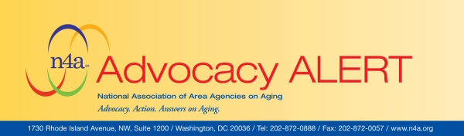
June 11, 2010

Keep Up the Pressure on Your Senators to Support the FMAP Extension to States
The $24 billion six-month extension of increased Medicaid funding in the ‘extenders’ bill has been restored, but passage of the bill remains uncertain.

The Senate continues to debate an amended tax and social programs extension bill (H.R. 4213) as Democratic leaders work to obtain the necessary 60 votes to move the legislation forward to a final vote next week. Earlier this week, Senate Democrats released an amended version of the extenders bill that restored a $24 billion six-month extension of additional Medicaid funding to states.

The Senate held a handful of votes this week on amendments to the bill, and other adjustments to the bill are being considered that include adding an extension of COBRA health care benefits for the unemployed (removed by the House) and lengthening the fix of the Medicare payment formula for physicians.

In order to surmount procedural hurdles in the Senate, the extenders bill must have the support of all 59 Democratic Senators and at least one Republican Senator. Efforts to move the bill this week stalled with a few Democrats expressing concerns about the bill’s tax provisions and key Republican moderates having concerns with the bill’s level of spending.

With critical Medicaid relief hanging in the balance, we must continue our advocacy push to urge all Senators to support the six-month FMAP extension and vote in favor of overall extenders bill.

Action Requested:

→ Call Your U.S. Senators in DC. You can reach them through the U.S. Capitol Switchboard at (202) 224-3121. Or you may wish to use this toll-free number 888-340-6521 provided by AFSCME.
→ Message: “I ask the Senator to support the six months of extra Medicaid help to states in the “extenders” bill and support the bill when it comes to a vote. Over thirty states have assumed the six-month extension of the Recovery Act FMAP increase in their budgets. If the extension is not approved by Congress, these states will be forced to reopen their budgets and make deeper cuts to Medicaid and other programs, including dramatic layoffs. This relief is essential to prevent harmful cuts to vital Medicaid programs and other home and community-based services for seniors in our state.”
Need More Information on FMAP and the Bill?

On May 28 before leaving for the week-long Memorial Day Recess, the House adopted changes to provisions in the extenders bill (H.R. 4213) that would block a scheduled 21 percent cut in Medicare reimbursements to physicians. Under the changes, an $88.5 billion five-year plan to prevent the reimbursement reductions for Medicare doctors was reduced to a $23 billion 19-month extension without incentives for primary and preventive care.

The vote was the second in a two-step process to send the bill back to the Senate. Earlier, the House passed the rest of the package, which includes a six-month extension of current unemployment benefits. However, last-minute negotiations with conservative Blue Dog Democrats resulted in a stripped-down bill that removed two key provisions: an extension until the end of this year of a federal COBRA subsidy for unemployed workers; and a $24 billion six-month extension of the temporary boost in federal matching funds for Medicaid.

Because the House and Senate could not reach an agreement, the last extension of the unemployment benefits, the “doc fix” and other provisions expired. The Senate is now debating its own amended version of the extenders bill which includes a restored FMAP extension as emergency spending, among other changes. It is now expected that the Senate will vote on the overall legislation next week.

If you have questions about this Advocacy Alert, please contact n4a’s Public Policy and Legislative Affairs staff, Amy Gotwals and KJ Hertz, at 202.872.0888 or agotwals@n4a.org, khertz@n4a.org.

